**TUGAS PENJAMIN KUALITAS PERANGKAT LUNAK**

PEMBUATAN WEBSITE BERITA BERBASIS WEB

<http://beritasport.epizy.com/>



Oleh :

WISNU SETIAWAN HADI

1800018071

PROGRAM STUDI TEKNIK INFORMATIKA

FAKULTAS TEKNOLOGI INDUSTRI

UNIVERSITAS AHMAD DAHLAN

2021

1. Tampilan Awal

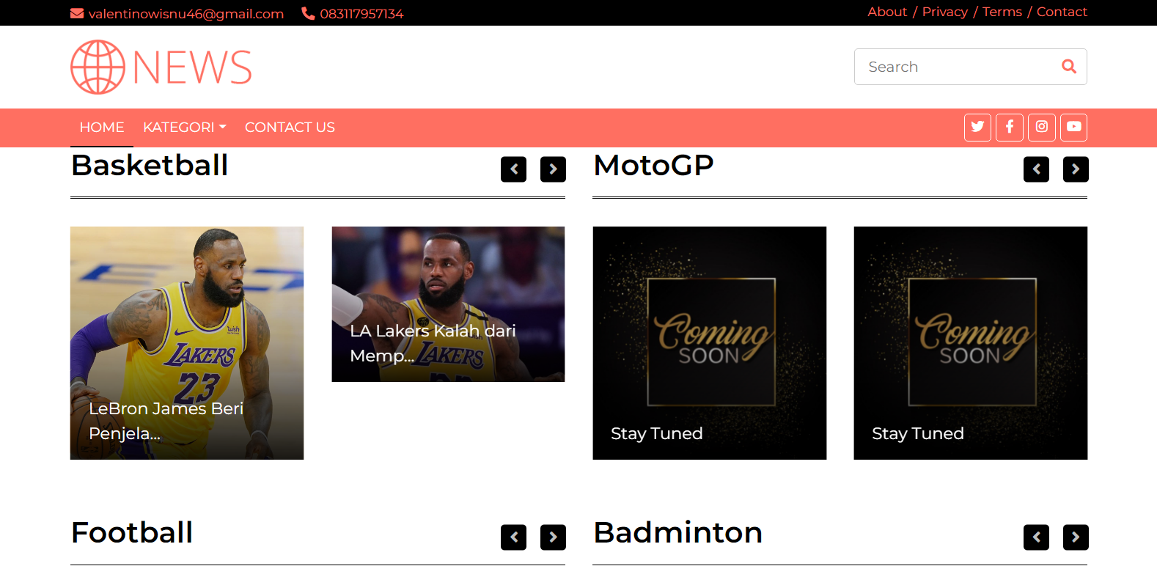

1. Diagram Path

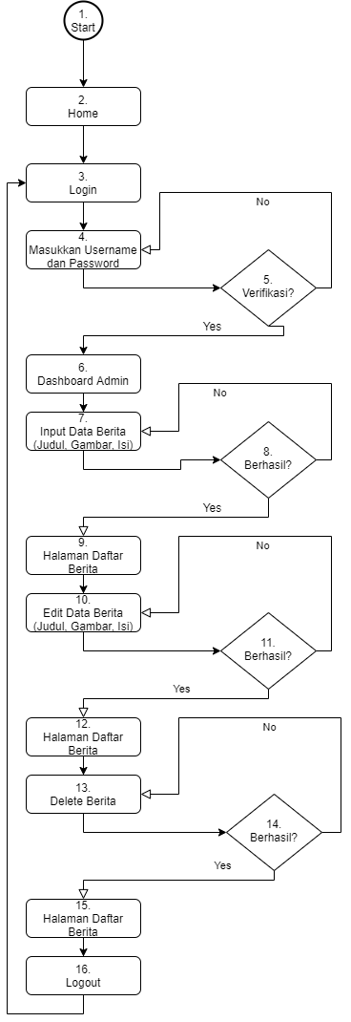

|  |  |
| --- | --- |
| Listing Code | |
| Controlers | <?php  defined('BASEPATH') or exit('No direct script access allowed');  class Berita extends CI_Controller  {  public function __construct()  {  parent::__construct();  $this->load->model('m_berita');  }  public function index()  {  $data = array(  'title' => 'ADMIN web sekolah',  'title2' => 'Daftar Berita',  'berita' => $this->m_berita->lists(),  'isi' => 'admin/berita/v_list'  );  $this->load->view('admin/layout/v_wrapper', $data, false);  }  public function add()  {  $this->form_validation->set_rules('judul_berita', 'Judul', 'required');  $this->form_validation->set_rules('isi_berita', 'Isi Berita', 'required', array('required' => '%s Harus Diisi'));  if ($this->form_validation->run() == TRUE) {  $config['upload_path'] = './gambar_berita/';  $config['allowed_types'] = 'gif|jpg|png';  $config['max_size'] = '2000';  $this->upload->initialize($config);  if (!$this->upload->do_upload('gambar_berita')) {  $data = array(  'title' => 'ADMIN web sekolah',  'title2' => 'Tambah Daftar Berita',  'error' => $this->upload->display_errors(),  'isi' => 'admin/berita/v_add'  );  $this->load->view('admin/layout/v_wrapper', $data, false);  } else {  $upload_data = array('uploads' => $this->upload->data());  $config['image_library'] = 'gd2';  $config['source_image'] = './gambar_berita/' . $upload_data['uploads']['file_name'];  $this->load->library('image_lib', $config);  $data = array(  'judul_berita' => $this->input->post('judul_berita'),  'slug_berita' => url_title($this->input->post('judul_berita'), 'dash', TRUE),  'isi_berita' => $this->input->post('isi_berita'),  'kategori_berita' => $this->input->post('katogori_berita'),  'tgl_berita' => date('Y-m-d'),  'id_user' => $this->session->userdata('id_user'),  'gambar_berita' => $upload_data['uploads']['file_name']  );  $this->m_berita->add($data);  $this->session->set_flashdata('pesan', 'Berhasil Di Simpan!');  redirect('berita');  }  }  $data = array(  'title' => 'ADMIN web sekolah',  'title2' => 'Add Berita',  'isi' => 'admin/berita/v_add'  );  $this->load->view('admin/layout/v_wrapper', $data, false);  }  public function edit($id_berita)  {  $this->form_validation->set_rules('judul_berita', 'Judul', 'required');  $this->form_validation->set_rules('isi_berita', 'Isi Berita', 'required', array('required' => '%s Harus Diisi'));  if ($this->form_validation->run() == TRUE) {  $config['upload_path'] = './gambar_berita/';  $config['allowed_types'] = 'gif|jpg|png';  $config['max_size'] = '2000';  $this->upload->initialize($config);  if (!$this->upload->do_upload('gambar_berita')) {  $data = array(  'title' => 'ADMIN web sekolah',  'title2' => 'Edit Berita',  'error' => $this->upload->display_errors(),  'berita' => $this->m_berita->detail($id_berita),  'isi' => 'admin/berita/v_edit'  );  $this->load->view('admin/layout/v_wrapper', $data, false);  } else {  $upload_data = array('uploads' => $this->upload->data());  $config['image_library'] = 'gd2';  $config['source_image'] = './gambar_berita/' . $upload_data['uploads']['file_name'];  $this->load->library('image_lib', $config);  $berita = $this->m_berita->detail($id_berita);  if ($berita->gambar_berita != "") {  unlink('./gambar_berita/' . $berita->gambar_berita);  }  $data = array(  'id_berita' => $id_berita,  'judul_berita' => $this->input->post('judul_berita'),  'slug_berita' => url_title($this->input->post('judul_berita'), 'dash', TRUE),  'isi_berita' => $this->input->post('isi_berita'),  'kategori_berita' => $this->input->post('kategori_berita'),  'id_user' => $this->session->userdata('id_user'),  'gambar_berita' => $upload_data['uploads']['file_name']  );  $this->m_berita->edit($data);  $this->session->set_flashdata('pesan', 'Berhasil Di Simpan!');  redirect('berita');  }  $data = array(  'id_berita' => $id_berita,  'judul_berita' => $this->input->post('judul_berita'),  'slug_berita' => url_title($this->input->post('judul_berita'), 'dash', TRUE),  'isi_berita' => $this->input->post('isi_berita'),  'kategori_berita' => $this->input->post('kategori_berita'),  'id_user' => $this->session->userdata('id_user'),  );  $this->m_berita->edit($data);  $this->session->set_flashdata('pesan', 'Berhasil Di Simpan!');  redirect('berita');  }  $data = array(  'title' => 'ADMIN web sekolah',  'title2' => 'Add Berita',  'berita' => $this->m_berita->detail($id_berita),  'isi' => 'admin/berita/v_edit'  );  $this->load->view('admin/layout/v_wrapper', $data, false);  }  public function delete($id_berita)  {  $berita = $this->m_berita->detail($id_berita);  if ($berita->gambar_berita != "") {  unlink('./gambar_berita/' . $berita->gambar_berita);  }  $data = array('id_berita' => $id_berita);  $this->m_berita->delete($data);  $this->session->set_flashdata('pesan', 'Data Berhasil Di hapus!');  redirect('berita');  }}  /* End of file Berita.php */ |
| Model | <?php  defined('BASEPATH') OR exit('No direct script access allowed');  class M_berita extends CI_Model {  public function lists(){    $this->db->select('*');  $this->db->from('tbl_berita');    $this->db->join('tbl_user', 'tbl_user.id_user = tbl_berita.id_user', 'left');    $this->db->order_by('id_berita', 'asc');  return $this->db->get()->result();    }  public function detail($id_berita){  $this->db->select('*');  $this->db->from('tbl_berita');    $this->db->where('id_berita', $id_berita);    return $this->db->get()->row();      }  public function add($data){    $this->db->insert('tbl_berita', $data);    }  public function edit($data){    $this->db->where('id_berita', $data['id_berita']);    $this->db->update('tbl_berita', $data);      }  public function delete($data){    $this->db->where('id_berita', $data['id_berita']);    $this->db->delete('tbl_berita', $data);      }  }  /* End of file M_berita.php */ |
| Views (Halaman Daftar Berita) | <div class="col-lg-12">  <div class="panel panel-primary">  <div class="panel-heading">  <a href="<?= base_url('berita/add'); ?>" class="btn btn-primary btn-sm" ><i class="fa fa-plus"></i> Add</a>  </div>  <div class="panel-body">  <?php  if ($this->session->flashdata('pesan')) {  echo'<div class="alert alert-success alert-dismissible">  <button type="button" class="close" data-dismiss="alert" aria-hidden="true">&times;</button>';  echo $this->session->flashdata('pesan');  echo '</div>';  }  ?>  <table class="table table-stripted table-bordered table-hover" id="dataTables-example">  <thead>  <tr>  <th>No</th>  <th>Judul</th>  <th>slug</th>  <th>Tanggal</th>  <th>Gambar</th>  <th>Nama User</th>  <th>Action</th>  </tr>  </thead>  <tbody>  <?php $no=1; foreach ($berita as $key => $value){ ?>  <tr>  <td><?= $no++; ?></td>  <td><?= $value->judul_berita ?></td>  <td><?= $value->slug_berita ?></td>  <td><?= $value->tgl_berita ?></td>  <td><img src="<?= base_url('gambar_berita/'.$value->gambar_berita) ?>" width="50px"></td>  <td><?= $value->nama_user ?></td>  <td>  <a href="<?= base_url('berita/edit/'.$value->id_berita) ?>" class="btn btn-xs btn-success"><i class="fa fa-pencil"></i></a>  <a href="<?= base_url('berita/delete/'.$value->id_berita) ?>" onclick="return confirm('Yakin?')" class="btn btn-xs btn-danger"><i class="fa fa-trash"></i></a>  </td>  </tr>  <?php } ?>  </tbody>  </table>  </div>  </div>  </div> |
| Views (Halaman Tambah Berita) | <div class="col-lg-12">  <div class="panel panel-primary">  <div class="panel-heading">  Add  </div>  <div class="panel-body">  <?php  if (isset($error_upload)) {  echo '<div class="alert alert-danger alert-dismissible">  <button type="button" class="close" data-dismiss="alert" aria-hidden="true">&times;</button>' . $error_upload . '</div>';  }  echo validation_errors('<div class="alert alert-danger alert-dismissible">  <button type="button" class="close" data-dismiss="alert" aria-hidden="true">&times;</button>', '</div>');  echo form_open_multipart('berita/add');  ?>  <div class="form-group">  <label>Judul</label>  <input class="form-control" type="text" name="judul_berita" placeholder="Judul Berita" required>  </div>  <div class="form-group">  <label>Gambar Berita</label>  <input type="file" class="form-control" type="text" name="gambar_berita" required>  </div>  <div class="form-group">  <label>Isi Berita</label>  <textarea name="isi_berita" id="editor"></textarea>  </div>  <div class="form-group">  <button type="submit" class="btn btn-primary">Simpan</button>  <button type="reset" class="btn btn-success">Reset</button>  </div>  <?php echo form_close(); ?>  </div>  </div>  </div> |
| Views (Halaman Edit Berita) | <div class="col-lg-12">  <div class="panel panel-primary">  <div class="panel-heading">  Edit  </div>  <div class="panel-body">  <?php  if (isset($error_upload)) {  echo '<div class="alert alert-danger alert-dismissible">  <button type="button" class="close" data-dismiss="alert" aria-hidden="true">&times;</button>' . $error_upload . '</div>';  }  echo validation_errors('<div class="alert alert-danger alert-dismissible">  <button type="button" class="close" data-dismiss="alert" aria-hidden="true">&times;</button>', '</div>');  echo form_open_multipart('berita/edit/' . $berita->id_berita);  ?>  <div class="form-group">  <label>Judul</label>  <input class="form-control" value="<?= $berita->judul_berita ?>" type="text" name="judul_berita" placeholder="Judul Berita" required>  </div>  <div class="form-group">  <label>Isi Berita</label>  <textarea name="isi_berita" id="editor"><?= $berita->isi_berita ?></textarea>  </div>  <div class="form-group">  <label>Gambar Berita</label>  <input type="file" class="form-control" type="text" name="gambar_berita">  </div>  <div class="form-group">  <button type="submit" class="btn btn-primary">Simpan</button>  <button type="reset" class="btn btn-success">Reset</button>  </div>  <?php echo form_close(); ?>  </div>  </div>  </div> |

1. Perhitungan Kompleksitas Siklomatis

Menghitung kompleksitas siklomatis dengan cara $lintasan bebas= jumlah kondisi atau predicate +1$. Jadi 4 + 1 = 5 yang artinya aka nada 5 lintasan bebas pada project yang saya buat.

1. Jalur Bebas

Jadi jalur bebasnya tergantung hasil dari perhitungan kompleksitas siklomatisnya yaitu 5, yang artinya aka nada 6 jalur bebas seperti di bawah ini :

1. 1 - 2 - 3 - 4 - 5 - 6 - 7 - 8 - 9 - 10 - 11 - 12 - 13 - 14 - 15 - 16
2. 1 - 2 - 3 - 4 - 5 - 4 - 5 - 6 - 7 - 8 - 9 - 10 - 11 - 12 - 13 - 14 - 15 - 16
3. 1 - 2 - 3 - 4 - 5 - 6 - 7 - 8 - 7 - 8 - 9 - 10 - 11 - 12 - 13 - 14 - 15 - 16
4. 1 - 2 - 3 - 4 - 5 - 6 - 7 - 8 - 9 - 10 - 11 - 10 - 11 - 12 - 13 - 14 - 15 - 16
5. 1 - 2 - 3 - 4 - 5 - 6 - 7 - 8 - 9 - 10 - 11 - 12 - 13 - 14 - 13 - 14 - 15 - 16
6. Hasil White Box dan Black Box (BVA)
7. Hasil Pengujian Input Data Berita
8. Hasil Pengujian Input Judul

Pada input judul tidak ada batasan jumlah huruf maupun spesifikasi inputanya hanya saja pada input judul harus diisi atau required.

|  |  |  |
| --- | --- | --- |
| Data Contoh | Hasil | Kesimpulan |
| - | Error | Gagal |
| Universitas Ahmad Dahlan | Success | Lolos |
| PKPL | Success | Lolos |

1. Hasil Pengujian Input Gambar

Pada input foto ini inputan atau format fotonya memiliki aturan yaitu harus format gif, jpg, dan png serta wajib diisi.

|  |  |  |
| --- | --- | --- |
| Data Contoh | Hasil | Kesimpulan |
| - | Error | Gagal |
| Uad.png | Success | Lolos |
| Herro.jpg | Success | Lolos |

1. Hasil Pengujian Input Isi

Pada input isi ini sama dengan input judul tidak ada syarat khusus tetapi harus wajib diisi, pada bagian isi ini apapun style tulisannya akan bisa diinpu.

|  |  |  |
| --- | --- | --- |
| Data Contoh | Hasil | Kesimpulan |
| - | Error | Gagal |
| Seorang Mahasiswa universitas Ahmad Dahlan sedang mengerjakan PKPL | Success | Lolos |
| Wisnu sedang mengerjakan matakuliah metopen | Success | Lolos |

1. Hasil Pengujian Edit Data Berita
2. Hasil Pengujian Input Judul

Pada pengujian input judul ini tidak ada syarat apapun tetapi jika dikosongkan maka tidak akan bisa diinput tetapi pada bagian edit ini jika tidak melakukan perubahan pada judul maka akan lolos juga.

|  |  |  |
| --- | --- | --- |
| Data Contoh | Hasil | Kesimpulan |
| - | Error | Gagal |
| Universitas Ahmad Dahlan | Success | Lolos |
| PKPL Semester 7 | Success | Lolos |

1. Hasil Pengujian Input Foto

Pada input foto ini inputan atau format fotonya memiliki aturan yaitu harus format gif, jpg, dan png serta jika tidak melakuka perubahan pada foto yang sebelumnya juga akan lolos dan gambar sebelumnya jika diubah akan terhapus pada folder tempat penyimpanan upload foto.

|  |  |  |
| --- | --- | --- |
| Data Contoh | Hasil | Kesimpulan |
| - | Error | Gagal |
| Uad.png | Success | Lolos |
| Herro1.jpg | Success | Lolos |

1. Hasil Pengujian Input Isi

Pada input isi ini sama dengan input judul tidak ada syarat khusus tetapi jika dikosongkan maka harus wajib diisi, pada bagian isi ini apapun style tulisannya akan bisa diinput dan jika tidak diubah maka tetap bisa di input.

|  |  |  |
| --- | --- | --- |
| Data Contoh | Hasil | Kesimpulan |
| - | Error | Gagal |
| Seorang Mahasiswa universitas Ahmad Dahlan sedang mengerjakan PKPL di Semester 7 | Success | Lolos |
| Wisnu sedang mengerjakan matakuliah metopen | Success | Lolos |

Jalur yang dilalui yaitu

* 1. 1 - 2 - 3 - 4 - 5 - 6 - 7 - 8 - 7 - 8 - 9 - 10 - 11 - 12 - 13 - 14 - 15 - 16
  2. 1 - 2 - 3 - 4 - 5 - 6 - 7 - 8 - 9 - 10 - 11 - 10 - 11 - 12 - 13 - 14 - 15 - 16

1. Uji Non-fungsional dengan JMetric
2. Capture File di Github
3. Penjelasan Screenshot Upload File di Github
4. Analisa Pengerjaan Projek Pengujian